**TC036 - Valid booking creation with Create booking with checkin date - past & checkout date – future**

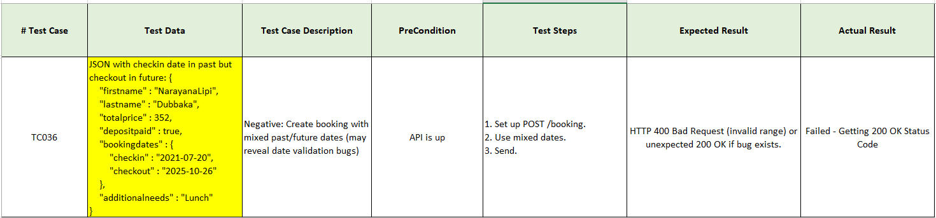

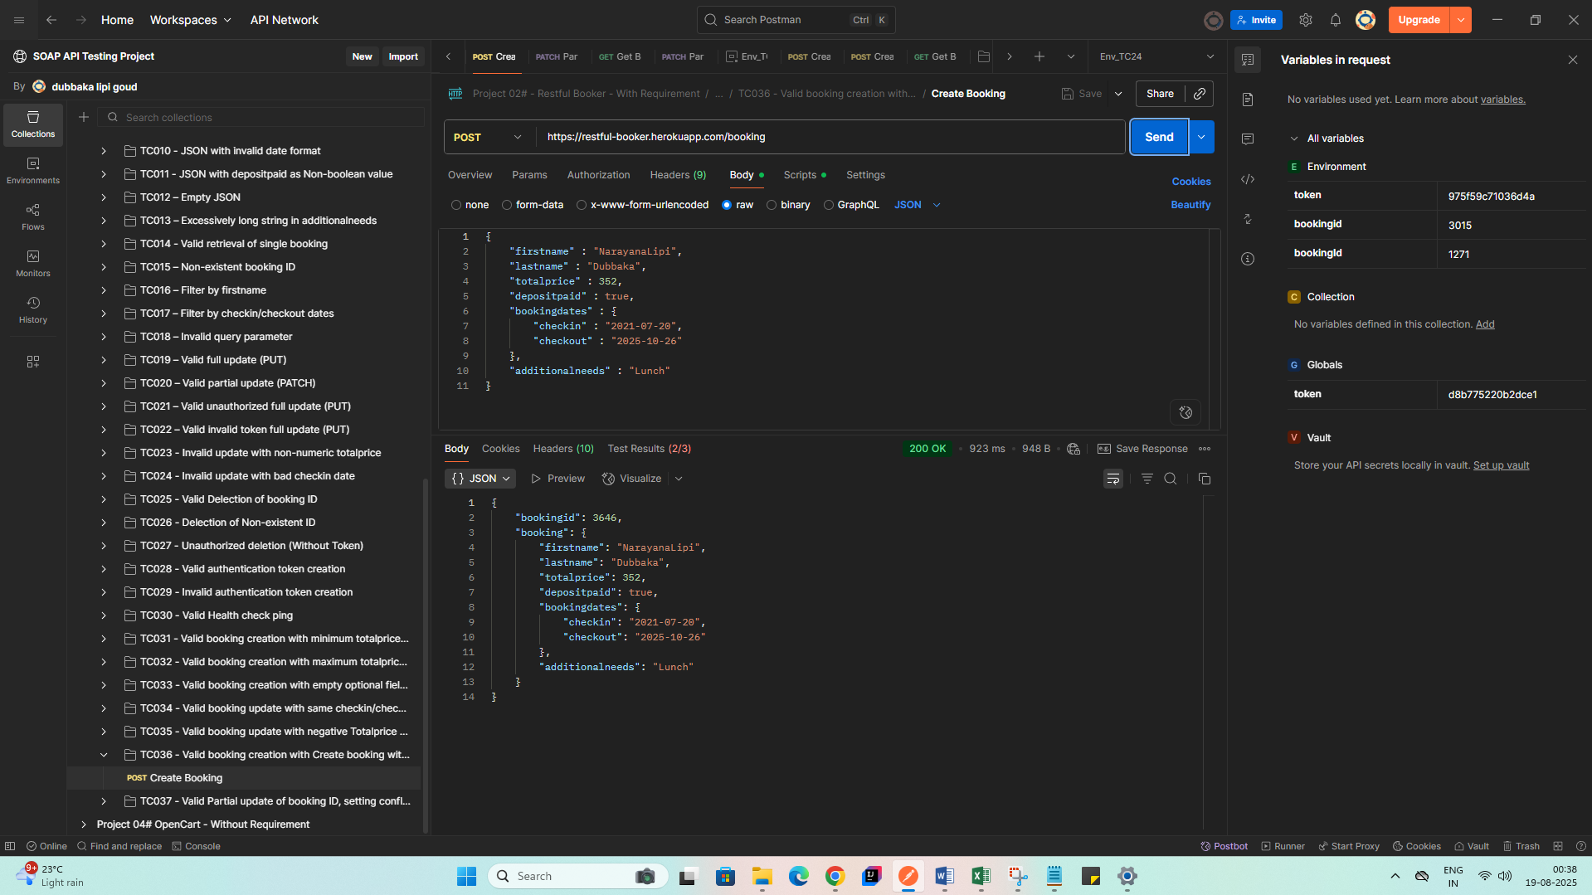

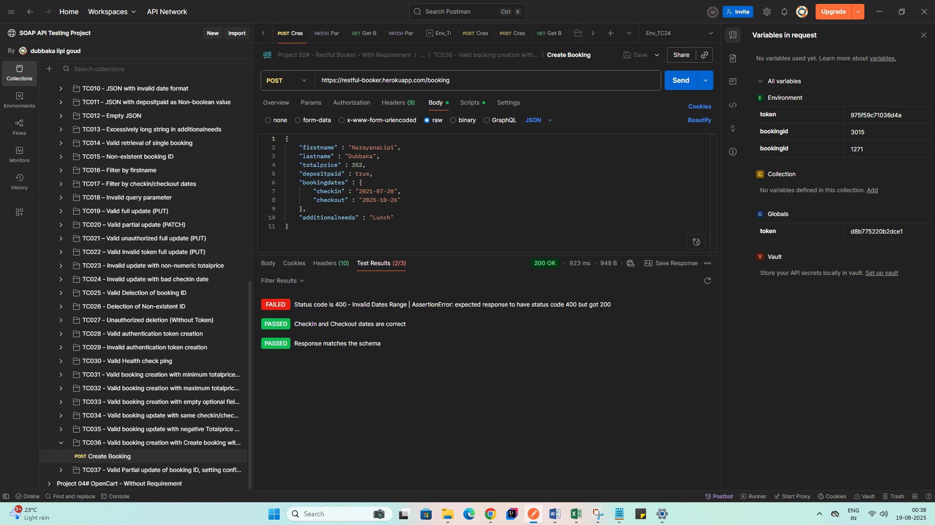

**Bug:** API does not validate date range correctly; it accepts checkin date in the past which should be invalid.

**Expected Result:**

* HTTP 400 Bad Request (invalid date range).

**Actual Result:**

* HTTP 200 OK with invalid date accepted.